**Bubble CPAP testing & validation summary** Date: 21-05-2018

**Purpose:**

An indigenous non-expensive Bubble CPAP system is developed for the resource poor parts of the world. To standardize & compare its performance for acceptance, some tests are conducted. During the operation cycle, a mild smell is detected in the breathing circuit as well. The below experiments are conducted to examine the following purposes.

1. To observe and understand the effect of change in different parameters such as Air Flow Rate, Pressure, Humidity, Temperature of the Bubble CPAP system.

* To determine the correlation of air flow and humidity level in breathing circuit.
* To determine the concentration of unwanted gases (CO, CO2 etc) & its variability in the breathing circuit.
* Effects & maximum rise in temperature & humidity levels during the working of the device.

1. The bubble CPAP system uses an oil-based air compressor (for lubrication in the motor). On continuous use, an oil-based system can release particulates. Hence, this test procedure checks the level of gases emitted, and compares emissions with standards.

**Introduction:**

Bubble CPAP is generally used in infants with respiratory abnormalities & apnea. CPAP therapy is given to such patients to help reduce breathing distress. Due to the higher cost of this device, it is not widely used in the Developing countries. This document will help eliminate this issue by allowing the users to build their own bubble CPAP system. Performance of such bubble CPAP device under low-resource settings is evaluated in this document. The following factors are most important while evaluating such DIY healthcare devices:

***Air quality [13] in the breathing circuit.***

Natural breathable air consists of mostly Nitrogen, Oxygen & a few other substances. In the presence of gaseous impurities & particulates, the air becomes toxic depending on the concentration of those substances.

Major pollutants[13] are Carbon Monoxide(CO2), Ozone(O3), Sulpher Oxides(SO2, SO3), Nitrogen Oxides(NO, NO2) & particulates matter. In the first experiment the concentration of impurities are identified to streamline the acceptable concentration range of different gas & materials under different climate & environmental conditions.

***Performance of the system***

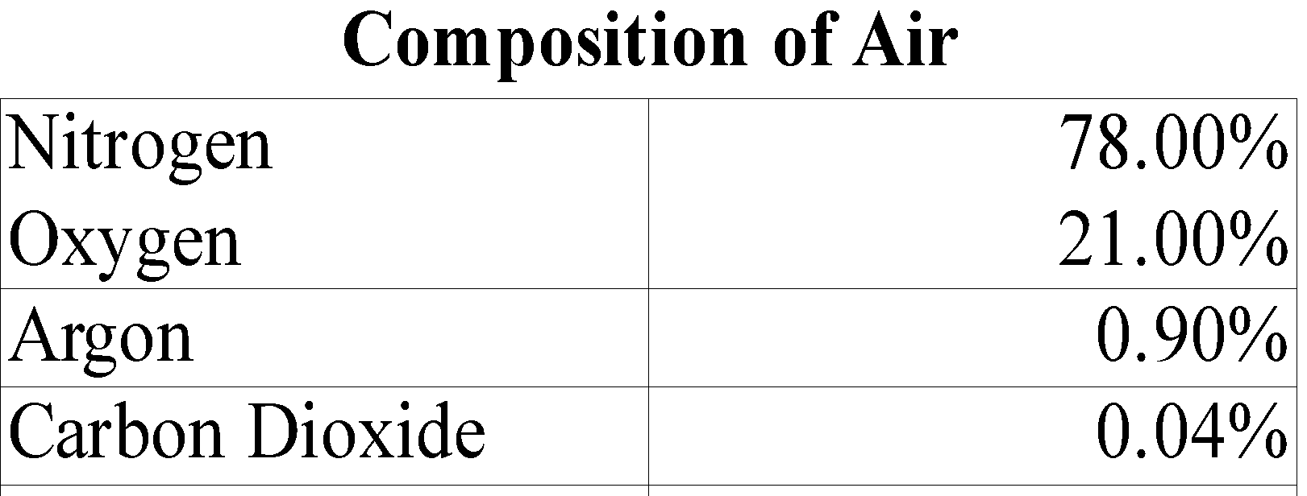

Repeatability, accuracy of performance of various components of the system such as air-compressor, humidifier, PEEP pressure consistency over hours of usage. It is also evaluated & documented to maintain a general acceptance standard & range across multiple devices.

**Materials used in this experiment:**

The test setup consists of the following items.

**1.** Bubble CPAP system with Air compressor, flow-meter, humidifier & PEEP; as shown in Fig.1.

**2.** Arduino Mega 2560 with USB & external power source since the USB port is incapable of providing the power required to drive all the sensors at once.

**3.** Flat Polypropylene sheet with the size of maximum internal area of the humidifier. Later that sheet is to be cut to expose different amount of the water surface area to air to manage humidity in the breathing circuit.

**4.** Sensor assembly.

The following sensors are deployed in the breathing circuit:

**Gas Sensors:** (For detecting level of concentration of the gases)

MQ-2 **[1]**: detects H2, LPG, CH4, CO, Alcohol, Propane.

MQ-5 **[2]**: detects LPG, Natural gas, Town gas.

MQ-135 **[3]**: detects NH3, C6H6, CO2.

**Temperature & Humidity Sensors:** (For collecting both ambient & relative data)

DHT11 [4]: 16 bit resolution temperature & relative humidity sensor.

**Pressure Measurement:** (For detecting leakage & measuring pressure)

PM-6205 [5]: HTC Instrument Digital Manometer with connection tubing.

**Flow Measurement:**

Dwyer Rate-master [6] flow-meter.

**Test Setup and Methods:**

In this experiment the following parameters are altered and observed in order to find the relationship between them.

* Flow rate **(1lpm to 10 lpm)**
* Humidifier water level **(1cm to 3cm)**
* Humidifier water surface area (**9.5cm x 15.5mm; 5% to 100%;** to control evaporation rate)
* Pressure level (**1cm to 10cm of H**2**O**)
* Temperature (**ambient & compressed Air**)
* Humidity (**ambient & compressed Air**)

Experiments are conducted to figure out the concentration level of potentially harmful gases. Digital manometer is used in to validate the pressure level of the breathing circuit and used more like a calibration device for the PEEP bottle water level markings. Kinking & leakage in breathing circuit is to be detected & resolved as well.

**Experiment: GAS concentration, Temperature & Humidity detection:**

The following testing environment is set up in order to investigate the amount of potentially harmful gases in the air passing through the breathing circuit and also to find out how change in one parameter affects the other. Pressure, Volume, rate of flow & Humidity level Ambient temperature & humidity are taken under consideration for this experiment.

CPAP device is set up as shown in Fig 1. Air compressor is connected to a 220 V wall socket. The Flow meter is directly connected to the compressor outlet.

Air flow through the breathing circuit is controlled by a pin valve provided in the flow meter that can deliver flow rates ranging from 1LPM to 10 LPM.



The next component in the breathing circuit is the Humidifier. Since evaporation occurs only on the surface of a liquid, small templates are created using PP sheets that covers certain areas of the water surface. Internal area of the humidifier is approx 9.5cm X 15.5 cm. We have found that the rate of change of humidity is directly proportional to the open surface of the water.

Data is collected using an embedded microcontroller attached to the sensors. The interval between each data point is 3 seconds.



3 pairs of humidity, temperature and gas sensors are deployed at the opening of the nasal prongs to detect the level of heat, moisture & gas concentration at both the ambient & test conditions. Ambient levels are required to calibrate the sensitivity of the sensors.

PEEP bottle has been marked with 0cm to 10cm H2O pressure levels. In this experimental setup the PEEP level is also variable & at each level, the same experiment to be carried out to understand the relation between humidity & gas concentration at different pressure levels.

The data has been collected using a microcontroller platform & sent to the PC using USB communication. A simple python script is written to automatically log it into a spreadsheet. Since there is very limited space in the internal EEPROM of the controller, data has been logged to a spreadsheet using serial programming & Python code. 

Analogue to Digital conversion values are used to calculate the PPM concentration of the gases.

**Data overview:**

In this experimental setup, data is collected while time is considered as an independent variable which plotted along the Y axis. A continuous set of 500 data points is logged at every level of flow rate (1 to 10 LPM) while taking all other parameters as constant.

*T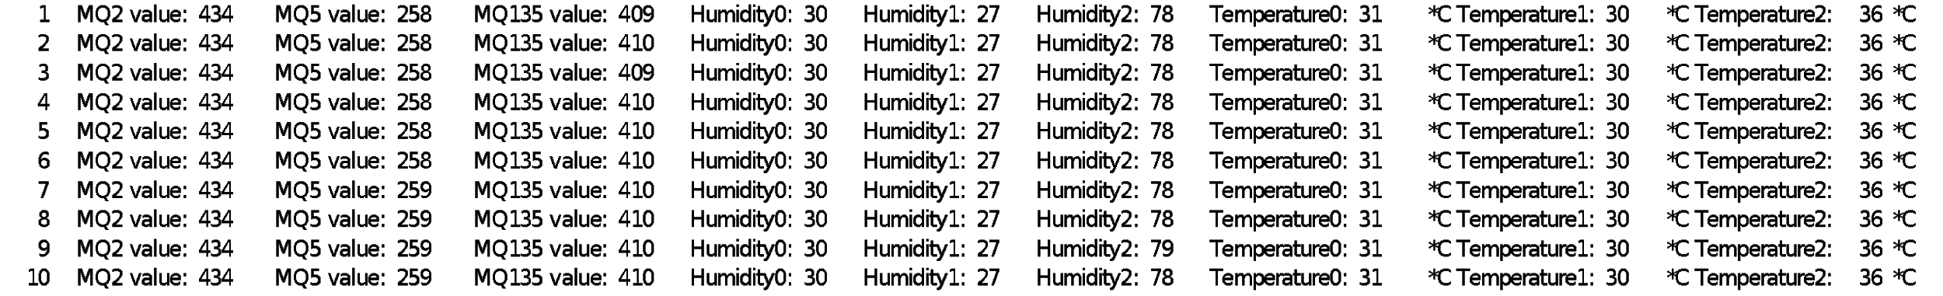able 1: Variable flow rate at 1 LPM & all other parameters are constant, Independent variable = time*

*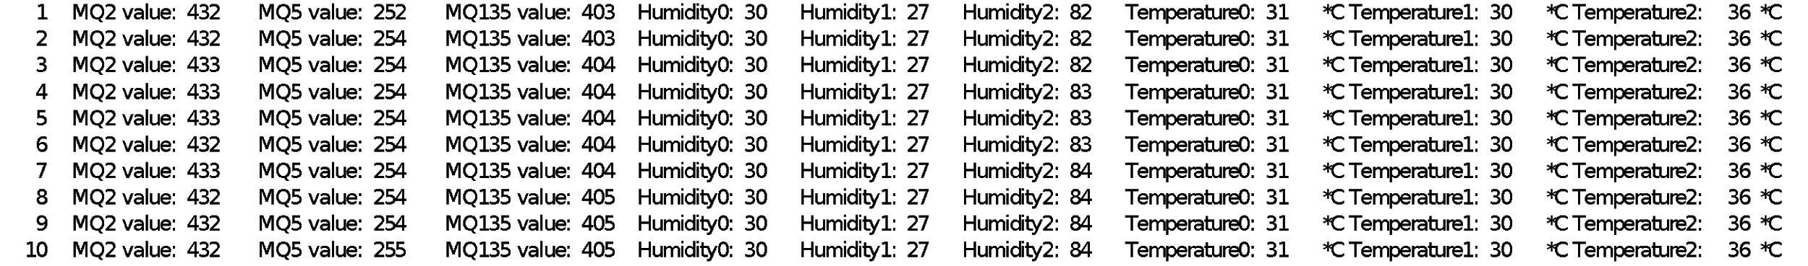Table2: Variable flow rate at 2 LPM & all other parameters are constant, Independent variable = time*

Total 3 sets of DHT11 relative humidity & temperature sensors are deployed in the system for obtaining both ambient & actual humidity & temperature levels in the breathing circuit.

Humidy0 and Humidity1 represents the ambient relative humidity levels

Humidity 2 represents the relative humidity level of the air circulating through the breathing circuit.

Similarly,Temperature0 & Temperature1 represents the ambient temperature.

Temperature2 is the core temperature of the air circulating through the breathing circuit.

The above humidity & temperature readings are required to calibrate the MQ series gas sensors. Datasheet & detailed PPM calculation sheet is attached for reference. Humidifier: open water surface, PEEP: 3cm H2O

*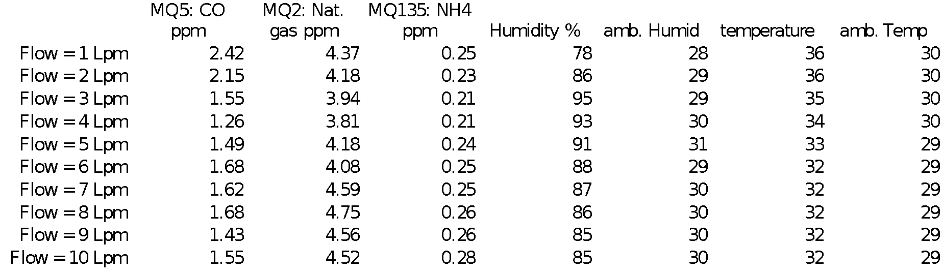 Table3: Gas sensor data, independent variable = flow rate*



The above plot is derived from table1, table2 & related set of data. In table 3, the average of one set of such data represents only one data point. This process can be repeated to get & analyze the entire data set at every flow rate, PEEP & humidifier water column and surface area.

Plot 1 represents the levels of unwanted gaseous impurities in the breathing circuit air. As observed in the experiment, the amount of Carbon monoxide, Propane & related organic compounds & ammonia levels are much below from the safety specifications.

These MQ gas sensors comes with the capability of detecting multiple gases using one sensor, in our experiment only three different gases are mentioned to reduce complexity in the analysis.

The whole list of detectable gases & their property curve is explained in detail in the datasheets.

Analog to digital conversion values are obtained from the gas sensors. These PPM values are then calculated using the ADC values & conversion formula.



Safety standards of the mentioned gases:

CO: 10ppm [7]

Propane: 25ppm [8]

Ammonia: 1000ppm [9]

**Experiment: PEEP pressure validation & Leakage identification**

The purpose & working of a CPAP system is entirely dependent on delivering the right amount of gases at the right pressure level to help the patient breath properly.

In order to make sure that the system is operating as expected, pressure validation using a calibrated manometer & leakage detection in the circuit is essential. 

This experiment is a continuation of the initial test setup as shown in Fig.1.

The digital manometer that is used in this experiment has dual pressure channel input for both positive and negative pressure measurement. Nasal prong is only & solely connected to the positive pressure measurement terminal of the manometer. To get the proper pressure levels it is to make sure that no air is leaking from the breathing circuit.

In this experiment, the obtained manometer reading is equal to the PEEP pressure adjusted in the bottle. Hence, it can be concluded that no significant air leaking from the breathing circuit is observed. 

At every PEEP level, the Flow rate is manually changed & the pressure reading from the manometer is documented in cmH2O unit. The same experiment is done for 1 to 10 cm water level.

**Leakage detection:**

For leakage detection, 3 way connectors are required to be fitted at different parts of the breathing circuit (Fig.1, at C, D & F sections). The differential pressure measurement feature of the manometer to be used for this purpose.

To measure differential pressure with respect to the PEEP level, the following connection circuit is to be followed.

1. Positive pressure probe is connected to the nasal prong (in RED).
2. Negative pressure probe is connected to junction C, D, or F (in BLUE).

In this setup, if there is any leakage in the breathing circuit, the differential pressure output will be a negative value.

**Data overview:**

PEEP is set at a specific height & airflow is changed at 1 lpm interval using the flow-meter knob. The manometer is set as configured in Fig.5.

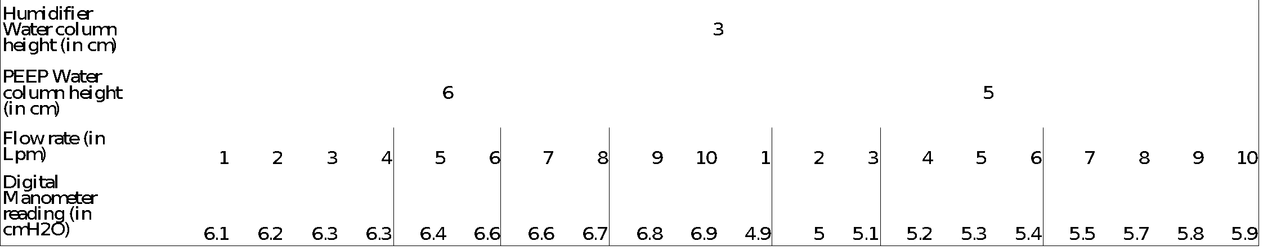Table 4: PEEP pressure values, independent variable = Flow Rate



Data received from digital manometer is plotted along Y axis.

Flow-meter set value is plotted along Y axis

PEEP water level pressure is denoted by the color of the lines.

**Experiment: Continuous run for 72 hours under ambient weather conditions:**

To ensure the working of the CPAP device over a long period of continuous usage, this experiment is conducted. For 72 hours the bubble CPAP prototype is kept in ON condition to observe temperature rise, component failure, humidifier evaporation rates etc.

For this test, the same experimental setup is used as mentioned in Fig.1 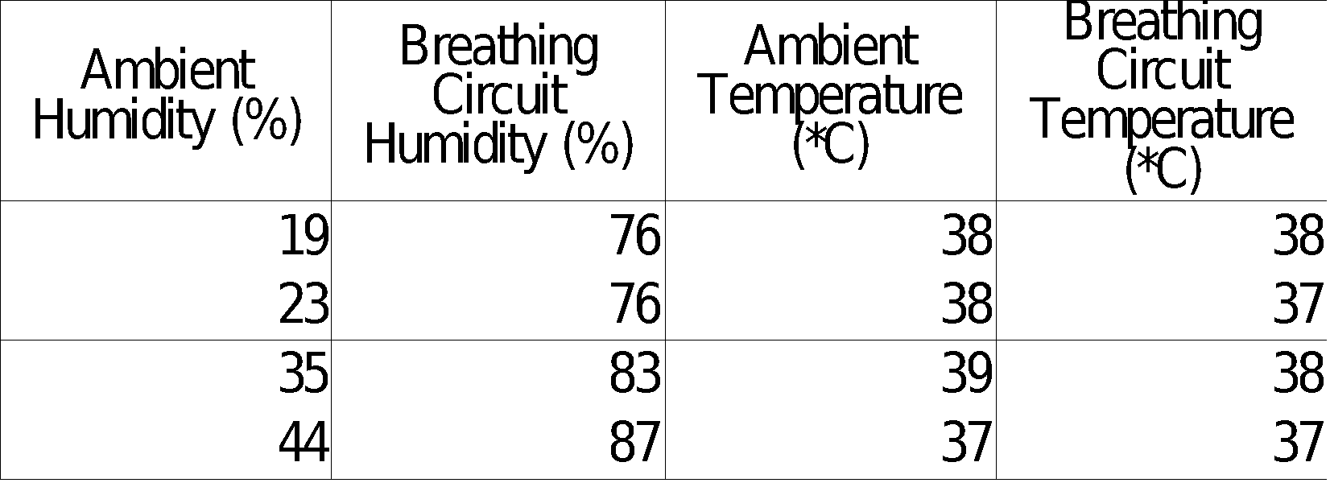with the following settings:

**Flow rate:** 5lpm;

**PEEP**: 5 cmH2O;

**Humidifier**: Entire water surface is exposed for full humidification.

**Test results:**

* Humidifier surface are of water = 15.5 x 9.5 sq. cm
* Decrement in water column over 12 hrs of usage = 1cm (at ambient temp. 38*C)
* Total evaporation = 15.5 x 9.5 x 1 cubic cm = 147.25 ml
* Rate of evaporation = 150ml (approx.) per 12 hours of continuous usage

**Observations:**

1. Mounting screws and internal assembly is not affected by continuous 8 hours run for 5 days. The Noise and vibration is not affecting the working of the CPAP device.
2. No significant level of harmful gases in the breathing circuit is found during the test run.
3. Water column height & area is altered to understand the relation between evaporation & humidification levels. Experimental measurements were made with minimal changes (3%) in ambient humidity.
4. Humidity beyond 85% for 2 lpm or higher flow rate, with ambient humidity at 30 +/- 1%.
5. Air compressor dissipates heat during the run. 3 temperature sensors are deployed; 2 for ambient & 1 at the outlet of the nasal prong to understand the rise of air temperature through the breathing circuit. Maximum temperature elevation is 6 degrees Celsius, with ambient temperature ranging from 29 to 30 degrees Celsius.
6. These results have been obtained in low ambient humidity (28-31% RH).
7. Approx rate of evaporation in humidifier is 150ml per 12 hours.
8. Air pressure is increased at 0.1cm per 1 lpm flow-rate[14] increment at any set PEEP level.

**Inference:**

1. The system delivers 80% or higher relative humidity, without saturating air. This is an ideal zone of operation, since it delivers moist air to babies, without risking irritation caused by saturated air that condenses and “spits”.
2. Ambient temperature and humidity are comparable to fields conditions in Uganda in summer.
3. The expected working range of this system is 4-6 lpm; in this zone, the system delivers consistent humidity and temperature.

**Additional Work:**

Leakage detection in the breathing circuit, pressure difference at different points of the circuit etc. to be verified.

The above experiment Carbon & Nitrogen based gases & their derivatives. A more robust & calibrated gas sensing technique [10] [11] can be adopted to identify the exact gases, oil & particles in the breathing circuit.

One most important part of the testing is to identify the microbial contamination in the system. [12]

**Appendix**

1. MQ2 Datasheet:

<https://www.pololu.com/file/0J309/MQ2.pdf>

1. MQ5 Datasheet:

<https://www.parallax.com/sites/default/files/downloads/605-00009-MQ-5-Datasheet.pdf>

1. MQ135 Datasheet:

<https://www.olimex.com/Products/Components/Sensors/SNS-MQ135/resources/SNS-MQ135.pdf>

1. DHT11 Datasheet:

<https://www.mouser.com/ds/2/758/DHT11-Technical-Data-Sheet-Translated-Version-1143054.pdf>

1. PM-6205 Datasheet:

<http://htcinstruments.com/images/PM-6102-6105-6115-6130-6175-6202-6205-1.pdf>

1. Dwer Flow master Datasheet:

<https://www.itm.com/pdfs/cache/www.itm.com/dwyer/flow_meter/rm_series/datasheet/dwyer_rm_series_flow_meter_datasheet.pdf>

1. Carbon Monoxide safe levels

<http://airtesting.com/wp-content/uploads/2017/04/Breathing-Air-Specifications-2017-2.pdf>

1. Propane & related gases safe levels

<https://www.ncbi.nlm.nih.gov/books/NBK201461/> paragraph. 2.2.2

1. Ammonia safe levels

<https://www.airgas.com/msds/001003.pdf> p.5, sec.8

1. <https://www.airbestpractices.com/standards/food-grade-air/sampling-and-testing-compressed-air-contaminants>
2. <https://www.airchecklab.com/services/manufacturing-iso-8573-1/>
3. 12. <https://www.ncbi.nlm.nih.gov/pmc/articles/PMC2556912/>
4. <http://web.mnstate.edu/marasing/CHEM102/Chapter%20Notes/Ch_01%20ho.pdf>
5. Effects of Flow Rate on Delivery of Bubble Continuous Positive Airway Pressure in an In Vitro Model p.216, Table 1.

<https://www.pediatr-neonatol.com/article/S1875-9572(10)60041-1/pdf>